Concatenate structures

<https://www.mathworks.com/help/matlab/matlab_prog/concatenate-structures.html>

Add cells to array

<https://www.mathworks.com/help/matlab/matlab_prog/add-cells-to-a-cell-array.html?searchHighlight=cells&s_tid=doc_srchtitle>

y = linspace([x1,x2](https://www.mathworks.com/help/matlab/ref/linspace.html#bud27em-x1x2)) returns a row vector of 100 evenly spaced points between x1 and x2.

y = linspace([x1,x2](https://www.mathworks.com/help/matlab/ref/linspace.html#bud27em-x1x2),[n](https://www.mathworks.com/help/matlab/ref/linspace.html#bud27em-n)) generates n points. The spacing between the points is (x2-x1)/(n-1).

y = linspace(1+2i,10+10i,8)

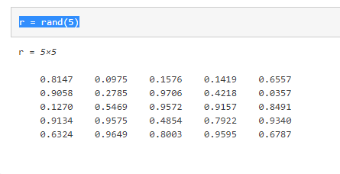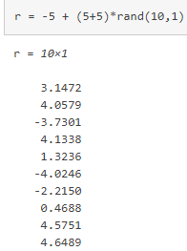

Normally distributed random numbers

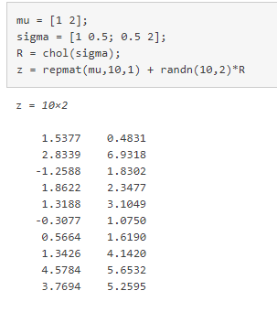

Mesh grids

<https://www.mathworks.com/help/matlab/ref/meshgrid.html>

LUPQ

